MED D – Long Term Care (LTC) Automated Claims Override

General Information
Verifying LTC Participant Residence in PeopleSafe
Viewing the LTC Override in PeopleSafe
Additional Guidance for Validating the LTC Automated Override
Log Activity
Resolution Time
Related Documents

Description: This document provides the MED D CCR with the process to override a Long Term Care (LTC) automated claim.

General Information
When a MED D beneficiary is in Long Term Care (LTC), the LTC pharmacy will submit a request for the beneficiary’s prescriptions to be refilled upon arrival or soon after.

Example: Beneficiaries are normally not allowed to bring their own medication to the LTC facility.
- So, the LTC pharmacy submits a request for a refill, and it is rejected for refill too early.
- Thus, forcing them to call in for an override.

Always review the Override Section in the Client's CIF to verify if Nursing Home/LTC Overrides are allowed.

Reminders:
- LTC pharmacies can request overrides for up to 90 days in the past, back-date the override to match the rejected fill date submitted by the pharmacy.
- If the claim is beyond 90 days in the past, the LTC Pharmacy will need to submit a Universal Claim Form (UFC) for reimbursement.

Top of the Document

Verifying LTC Participant Residence in PeopleSafe
When the MED D Customer Care Representative (CCR) receives a call from a LTC Pharmacy requesting a LTC Override, the CCR must verify the Participant Residence in PeopleSafe to see if the beneficiary is eligible for Nursing Home/LTC Override.

These steps will determine if a beneficiary is eligible for a Nursing Home/LTC Override in PeopleSafe, however if the LTC Pharmacy has additional questions regarding Participant Residence Values or how to submit the claim properly, the CCR should transfer the caller to the Pharmacy Help Desk (PHD).

Step | Action
1 | From the MAIN screen, click on the Prescription Number link.  Result: The Prescription Details screen will display.
2 | Click on Show next to General at the bottom left.  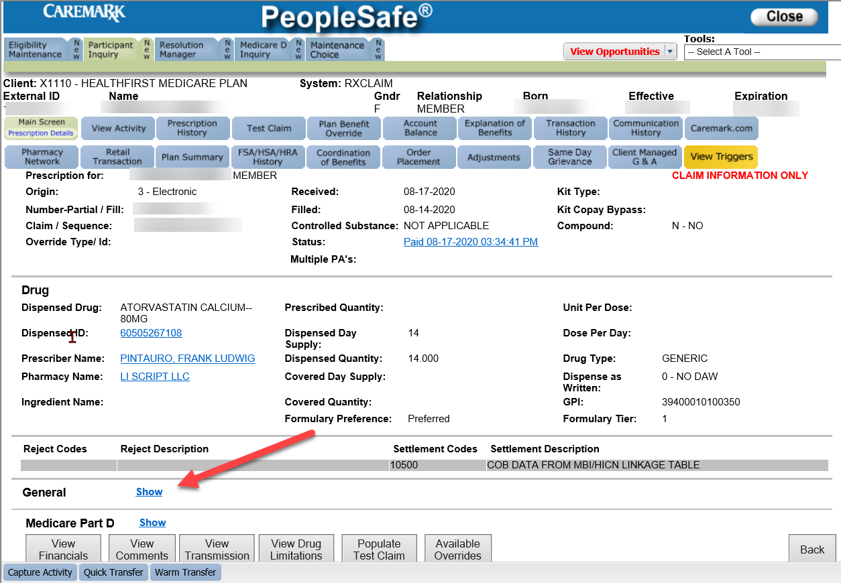
3 | Review the Participant Residence field.  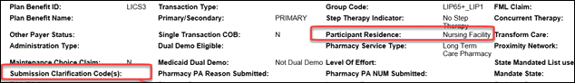  - Participant Residence must state either:  - 03 – Nursing Facility – A facility which primarily provides to residents skilled nursing care and related services for the rehabilitation of injured, disabled, or sick persons, or, on a regular basic, health-related care services above the level of custodial care to other than mentally retarded individuals.  - 09 – Intermediate Care Facilities for Individuals with Intellectual Disabilities (ICF’s/IID) – A facility which primarily provides health-related care and services above the level of custodial care to mentally retarded individuals but does not provide the level of care or treatment available in a hospital or SNF.  Notes:  - Patient Residence 04 – Assisted Living Facility DO NOT qualify for LTC overrides.  - If the pharmacy used a SCC code, you can view the override reason in the Submission Clarification Code(s) field.
4 | Answer any questions from the LTC pharmacy or beneficiary according to existing policies and procedures.  Note: The CCR can validate if the LTC Override was used, but for more detailed questions, questions regarding how to submit the claim or if the SCC Code did not bypass the rejection, the CCR will warm transfer the LTC Pharmacy caller to the Pharmacy Help Desk at 1-866-693-4620.

Top of the Document

Viewing the LTC Override in PeopleSafe
When the MED D Customer Care Representative (CCR) receives a call from a LTC Pharmacy questioning whether or not the LTC Override was used or a call from the beneficiary requesting why their prescription request was rejected, the CCR can view this detail in PeopleSafe.

These steps will provide guidance for viewing the LTC Override in PeopleSafe, however if the LTC Pharmacy has additional questions regarding the use of the LTC Override codes or how to submit the claim properly, the CCR should transfer the caller to the Pharmacy Help Desk (PHD).
Step | Action
1 | From the MAIN screen, click on the Prescription Number link.  Result: The Prescription Details screen will display  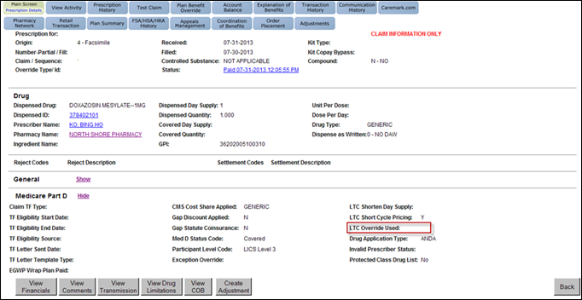  The LTC Override USED field will show one of the following:
1 | If the letter… |  | Then…
1 | Y (yes) appears in this field |  | The LTC Override has been used and if all other aspects of the claim are correct should pay.  Note: If the LTC Pharmacy needs assistance in ensuring all values are correct they should contact or be transferred to the Pharmacy Help Desk at 1-866-693-4620.
1 | N (no) or blank |  | The LTC Override was NOT used or did not work; the pharmacy should be warm transferred to the Pharmacy Help Desk (PHD) at 1-866-693-4620.
2 | Answer any questions from the LTC pharmacy or beneficiary according to existing policies and procedures.  Note: The CCR can validate if the LTC Override was used, but for more detailed questions or questions regarding how to submit the claim, the CCR will warm transfer the LTC Pharmacy caller to the Pharmacy Help Desk at 1-866-693-4620.
3 | Ask if there are any other benefit questions.
3 | If… | Then…
3 | Yes | Address any benefit issues per the HIPAA Authentication Grid.
3 | No | Proceed to Step 5.
4 | Close the call according to existing policies and procedures.

Top of the Document

Additional Guidance for Validating the LTC Automated Override
In order to activate the LTC Automated Override:
- The LTC Pharmacy will submit a Submission Clarification Code which will auto-override the too early to refill reject.
- The adjudication engine will recognize these codes as LTC and will NOT reject.
- The system will create an auto-override and allow the claim to pay.

The CCR will follow these steps in order to review the LTC Pharmacy Submission Clarification Codes:
Step | Action
1 | From the MAIN screen, click on the Prescription Number link.  Result: PeopleSafe will display the Prescription Details screen.
2 | Click on the show hyperlink the General section  Result: The information on the Prescription Details screen will expand and provide the Submission Clarification Code details.  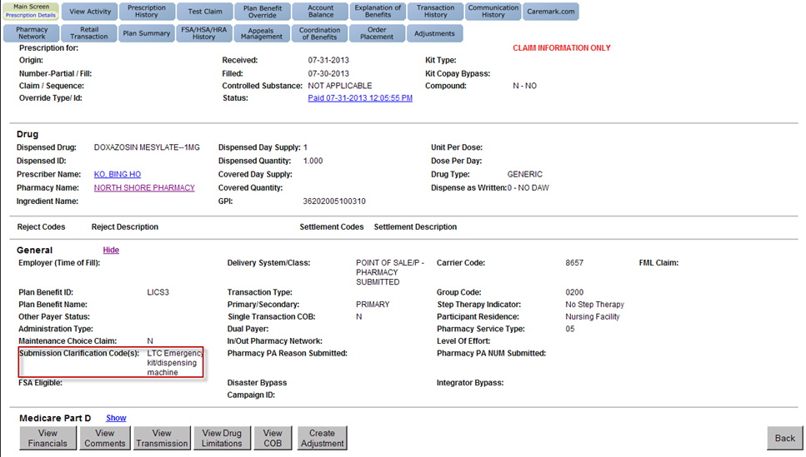  The LTC Pharmacy will supply one of the following for:  Do not attempt to assist the LTC Pharmacy with questions regarding the submission of the claim.  - Warm transfer the call to the Pharmacy Help Desk at 1-866-693-4620.
2 | SCC Code: 14- Vacation Supply/Leave Of Absence 5-day supply allowance |  | Separate dispensing of small quantities of medications for take-home use allowing beneficiaries to leave facility for weekend visits, holidays, etc.
2 | SCC Code: 04- Drug Missing, Dropped or Lost 5-day supply allowance |  | The beneficiary is requesting a replacement of medication that has been lost/misplaced.
2 | SCC Code: 17- First Fill Following Emergency Box Dose |  | Follow-up fill after Emergency dose has been dispensed. This prescription should be filled for the full prescribed amount minus the Emergency Dosing.
2 | SCC Code: 07- Emergency Supply 31-day supply allowance |  | Emergency supply of non-formulary drugs & formulary w/ PA or Step Therapy Requirements.
2 | SCC Code: 16- Emergency Box 5-day supply allowance |  | The beneficiary is receiving a fill from the Emergency Box, until standard supply can be dispensed.
2 | SCC Code: 18- LTC Admission/ Level of Care Change 31 days supply allowance |  | Identifies the beneficiary as a new patient. Beneficiary moved to new facility.
2 | SCC Code: 15- Patient “Spit Out” 5-day supply allowance |  | Patient spit out medication.
3 | Answer any questions from the LTC pharmacy or beneficiary according to existing policies and procedures.  Note: The CCR can validate if the LTC Override was used, but for more detailed questions or questions regarding how to submit the claim, the CCR will warm transfer the LTC Pharmacy caller to the Pharmacy Help Desk at 1-866-693-4620.
4 | Ask if there are any other benefit questions.
4 | If… | Then…
4 | Yes | Address any benefit issues per the HIPAA Authentication Grid.
4 | No | Proceed to Step 6.
5 | Close the call according to existing policies and procedures.

Top of the Document

Log Activity
913 – Retail Asst with Transmission
602 – Claim Status
Top of the Document

Resolution Time
Varies depending on various claims processing issues

Top of the Document

Related Documents
- MED D - Senior Team - Override Reason Chart Job Aid

Parent SOP: CALL-0048: Medicare Part D Customer Care Call Center Requirements-CVS Caremark Part D Services, L.L.C.
Abbreviations/Definitions: Abbreviations / Definitions

Top of the Document

Not to Be Reproduced or Disclosed to Others without Prior Written Approval
ELECTRONIC DATA = OFFICIAL VERSION – PAPER COPY = INFORMATIONAL ONLY

